**Test Framework Design Approach**

**Objective:** To design Automation framework to test Rest APIs using BDD approach.

**Tools used**: Below tools has been used in this framework

1.Eclipse

2.Maven

3.Junit & java

4.Cucumber

5.RestAssured

6.Jackson API

**Components of framework**:

1. Feature files: In Feature file , we write our scenarios in plain gherkin language using Given, When, Then ,And
2. Step definition file: In Step definition file , we write actual logic behind every steps mentioned in
3. Test Runner file: Using Test runner file we run scenarios and generate reports.
4. Pojo Class: Pojo class used for serialization and deserialization of Json data.
5. Other Resource: We used properties file to define global variables and utility class to define common reusable functions.

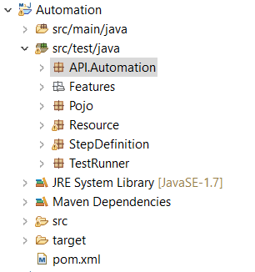

**Data Handling:** Here data is sending from feature file using Example keyword.

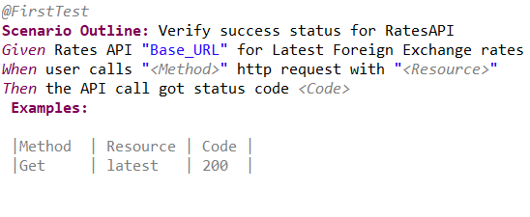

**Reporting:** Cucumber HTML reports getting generate after execution

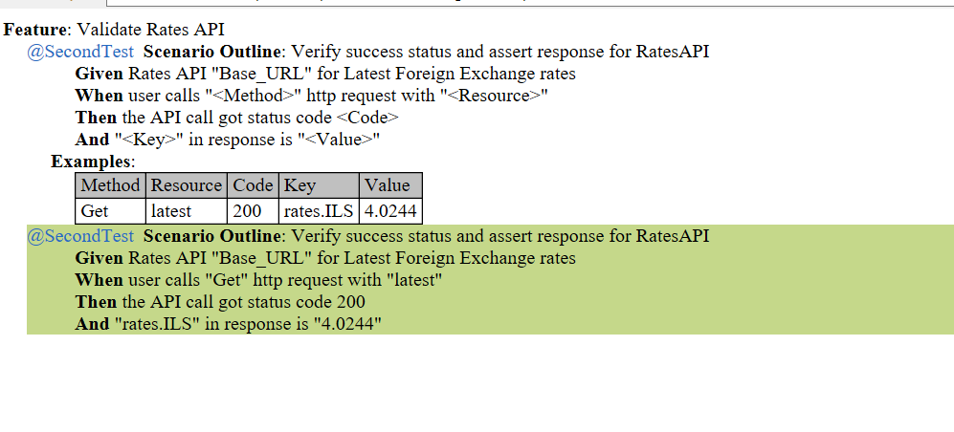

**Dependencies:** Added required dependencies in pom.xml

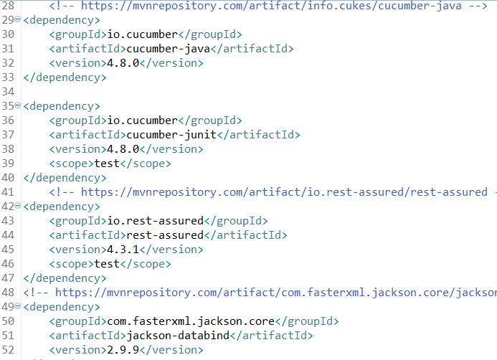

**Test Flow explanation:**

**Step 1:** Created Maven Project and added all required dependencies in Pom.xml

**Step 2:** Created Feature file and write scenario according to requirement using gherkin language. Providing data using examples and properties file

**Step 3:** Added step definition for each steps mentioned in feature. Implemented actual logic using rest assured and java. Used POJO class to access data from response. All validation part included here.

**Step 4:** Created test runner file in which we added feature file and step definition. Also added type of report we want to generate

**Step 5:** After Execution HTML report will generate.